Yuvraj Singh Kushwah
+91 78060 24141 | yuvrajsk.bpl@gmail.com | linkedin.com/in/yuvrajsinghkushwah | web-portfolio.app

December 5, 2025

To the Deputy Director General (HR/Tech), Unique Identification Authority of India (UIDAI), Headquarters / Technology Centre.

Re: Application for Internship Program 2025 – Technology Track (Data Science/Data An- alytics/AI)

Dear Sir/Madam,
Aadhaar is not just an identity framework; it is the bedrock of India’s Digital Public Infras- tructure (DPI). As a final-year Data Science undergraduate with a 9.04 CGPA and specialized expertise in building scalable, low-latency AI systems, I am writing to express my strong de- sire to contribute to UIDAI’s mission of empowering residents with secure and efficient digital identity services. I am eager to apply my technical rigor in Machine Learning Optimization, Signal Processing, and Fraud Analytics to support the technological advancements at the UIDAI Technology Centre.
While my academic background provides a strong foundation, my project portfolio demon- strates my ability to engineer solutions for scale, security, and efficiency—core pillars of the Aadhaar ecosystem. My suitability for this internship is defined by three key competencies:
- High-Performance System Engineering (Latency Optimization): In my “High-Efficiency Predictive Resource Engine” project, I did not just build a model; I optimized it for deploy- ment on constrained hardware. By utilizing PyTorch CUDA acceleration and feature decou- pling, I reduced inference latency to <1ms and cut memory usage by 50%. This experience is directly transferable to optimizing biometric authentication requests where millisecond- level responsiveness is critical for user experience.
- Advanced Signal Processing & AI (ORBITUNE): Through my innovative project “ORBITUNE,” I engineered a system that uses Digital Signal Processing (DSP) and Machine Learning to transform raw audio streams into immersive formats. This hands-on experience with signal transformation and noise reduction algorithms is highly relevant to enhancing the quality and accuracy of biometric data capture (voice/face/iris) in diverse environmental conditions.
- Data Security & Integrity Pipelines: Developing “CONTRA,” a secure data retrieval pipeline, required me to build robust API integrations that aggregate real-time data while maintaining consistency. Coupled with my experience in Fraud Analytics (JPMorgan Virtual Internship), where I modeled default probabilities to detect anomalies, I bring a security-first mindset es- sential for protecting the integrity of resident data.
Beyond technical skills, I possess a deep commitment to public service and operational excel- lence. As the Operations Lead for two major hackathons (400+ attendees), I demonstrated the ability to manage cross-functional teams and deliver logistical success under pressure—qual- ities I aim to bring to UIDAI’s dynamic work environment.
I am available for an immediate start and am willing to relocate to Bengaluru, Chandigarh, Mumbai, Ranchi, Hyderabad, Lucknow or New Delhi as required. Thank you for considering my application to serve the nation’s premier digital authority.

Sincerely,

Yuvraj Singh Kushwah

Yuvraj Singh Kushwah
Data Scientist


 +91-7806024141 yuvrajsk.bpl@gmail.com
linkedin.com/in/yuvrajsinghkushwah
portfolio.vercel.app
Summary
High-achieving Data Science undergraduate (9.04 CGPA) with specialized expertise in AI Model Optimization, Cloud Infrastructure, Data-Analysis and intelligent insight generation from data. Proven track record of developing low-latency predictive systems (less than 1ms) and secure data pipelines. Seeking to leverage technical skills in large-scale data processing and algorithmic efficiency to contribute to the Unique Identification Authority of India (UIDAI) technology initiatives and Digital Public Infrastructure (DPI).
Education
BCA Hons. in Data Science Graduation in: 2026
Jagran Lakecity University, Bhopal, Madhya Pradesh CGPA: 9.04 / 10
Skills
Programming & Querying: SQL, Python
Data Visualization Tools: Advanced MS Excel, Power BI, Tableau
Analytical Abilities: Data Cleaning, Exploratory Data Analysis (EDA), Insight Generation, Descriptive Statistics ML and AI: Machine Learning, Deep Learning, Generative AI, AI Automation, Model Evaluation, Feature Engineering
Experience

Deloitte Australia Data Analytics Job Simulation on Forage Nov 2025
Job Simulation (Remote) Tools Used: Tableau, Excel
- Developed interactive dashboards in Tableau to visualize forensic data patterns, aiding in the identification of data inconsistencies and potential irregularities.
- Conducted root-cause analysis on complex datasets to drive evidence-based decision-making for risk mitigation.

JPMorgan Chase & Co. Quantitative Research (Virtual Internship) Nov 2025
Data Analytics (Remote) Tools Used: Python, Matplotlib, scikit-learn, StatsModels
- Analyzed large-scale loan datasets to estimate default probability, employing dynamic programming techniques relevant to identifying financial fraud and anomalies.
- Engineered categorical features from credit scores to enhance predictive accuracy, demonstrating capability in handling sensitive user data profiles safely.
Projects
CONTRA - AI-Driven Data-to-Art and Storytelling Platform | Python, TensorFlow, Stable Diffusion, LLaMA
- Developed an AI platform that transforms text into contextual narratives, visuals, and chatbot interactions.
- Engineered APIs integrating LLaMA and Stable Diffusion for narrative and image generation.
- Built data pipelines combining Wikipedia, DBpedia, and GNews for real-time contextual enrichment.

ORBITUNE - AI-Powered 16D Music Experience | Python, Librosa, Demucs, FFmpeg, Gemini API
- Created an AI system converting stereo tracks into immersive 16D audio using DSP and ML.
- Integrated an emotion-aware chatbot for mood detection and personalized music recommendations.

Smart Product Pricing Regression Challenge | Python, XGBoost, CLIP, DeBERTa-v3
- Built a multimodal regression pipeline fusing image, text, and numerical features for optimal pricing.
- Optimized SMAPE metric under hardware limits (RTX 4050, 6GB VRAM) through feature–training decoupling.
- Achieved sub-30% SMAPE score with a stable and high-performing XGBoost model.
Awards & Certifications
  - Oracle Cloud Infrastructure 2025 Certified Generative AI Professional
  - Oracle Cloud Infrastructure 2025 Certified AI Foundations Associate
  - CodeWithHarry’s The Ultimate Job Ready Data Science Course
  - Achievement of Academic Excellence Award (100% scholarship)
  - Led operations for 2 annual hackathons (400+ attendees), achieving 100% logistical success.

Annexure “A”
Proforma of Application for Internship in UIDAI
- Registration No :
- Name : Yuvraj Singh Kushwah
- Father’s Name : K.L. Kushwah
- Address for correspondence : Bheem Nagar, near Kali mandir, Bhopal, M.P.
- Contact Number : 7806024141
- E-mail : yuvrajsk.bpl@gmail.com
- Date of Birth : 12/08/2006
- Educational Qualification (Starting from 12th onward)

Sl N  o | Name of  Board/Universi ty/Institute | Course details | Discipline | Year of Joining  (month/yea r) | Pursuing/ Completed | Consolidated/  cumulative Percentage/  Grade/CGPA as on final/Last Semester/year attended
1 | Jagran Lakecity University | Bachelors’s of Computer Applications  Hons. | Data Science | August/2023 | Pursuing | 9.04 CGPA
2 | Anand Vihar School | 12th, PCM | Science | March/2022 | Completed | 74.4%

- Place of Internship : Technology Centre, Bengaluru and Headquarters, New Delhi
- In case of Head Office, preferred functional wing ( Kindly refer annexure-F):
Technology Management Division

- Period of Internship (2 months/6 months etc.) : Preferred 3 months ( but can be expanded as mush as needed)
- Desired Month for commencement (2026-2027) : 5 January 2026
- Area of interest (please indicate courses taken/certification done which qualify you for the role) : Data Science/ Data Analytics, Artificial Intelligence
Relevant Certifications:
  - Deloitte Data Analytics Job - Completed a practical virtual internship focused on data analytics and forensic investigations. The role involved analyzing client telemetry data, performing data modeling, and presenting data visualization tools. The key deliverable was the creation of an interactive dashboard in Tableau to explore data and present insights.

  - J.P. Morgan Quantitative Research Virtual Internship - Successfully completed the JPMorgan Chase &C. Quantitative Research Virtual Experience Program, mastering practical skills in financial data analysis and algorithmic trading. This intensive simulation involved developing and back testing a quantitative trading model, utilizing Python and key libraries to analyse complex datasets and identify market signals. I further honed my analytical acuity by evaluating model performance, assessing portfolio risk metrics, and articulating data-driven strategies, demonstrating a comprehensive understanding of the quantitative research lifecycle.
  - Oracle Cloud Infrastructure Generative AI Professional – Oracle Certified, learnt Fundamentals of LLms, OCI Generative AI Services, RAG using Gen AI Services and Oracle 23 AI Vector Search, Chatbot using Gen AI Agent Service.
  - Oracle Cloud Infrastructure 2025 Certified AI Foundations Associate – Oracle Certified, learnt Machine Learning, Deep, Learning, Generative AI and Llm Foundation, OCI AI Portfolio, OCI Gen AI Services, OCI AI Services.
- Remarks (In brief not exceeding 50 words):

A detail-oriented analyst with proven quantitative aptitude. I am motivated to leverage my skills in machine learning and statistical analysis to tackle UIDAI's unique data challenges and deliver impactful, data-driven solutions.


I declare that the information given by me is true, correct and to the best of my knowledge and nothing has been concealed

Date: 10/11/2025 Name & Signature: Yuvraj Singh Kushwah

Annexure-I

UNDERTAKING

- I will follow the rules and regulations of the Authority that are in general applicable to employees of the authority.
- I will follow the strict confidentiality protocol of the Authority and shall not reveal to any person or organization confidential information on the Authority, its work and its policies.
- Any papers and documents written (if any) and / or published by me will carry the caveat that the view are the personal views of the intern and do not represent or reflect the view of the authority.
- I will conduct myself professionally in my relationship with the Authority and the Public in general. I will enter into the "Non-Disclosure Agreement" with UIDAl on joining.


Place: Bhopal, Madhya Pradesh

Date: 10/11/2025 Name & Signature of the Candidate: Yuvraj Singh Kushwah

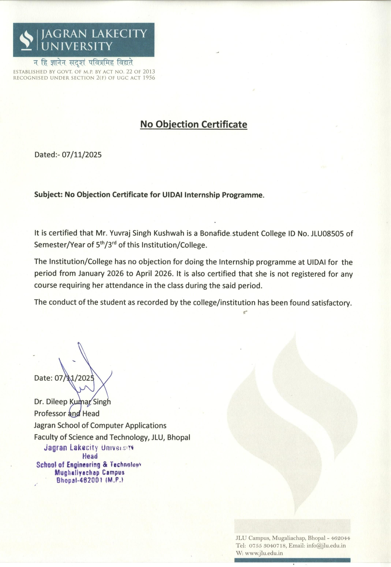

him

